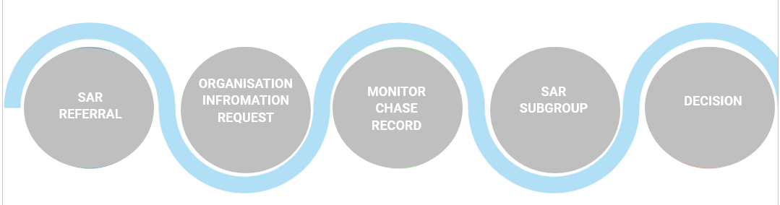

**Declined Referral**

After the decision has been made, the SAR subgroup will inform the referrer of the reason behind why the SAR did not meet the criteria. If the referrer or referrer’s organisation disagrees with the decision, they can contact RSAB at [RSAB@rotherham.gov.uk](mailto:RSAB@rotherham.gov.uk).

**Safeguarding Adult Review Pathway**

**Decision Making**

The decision will be made by the members of the SAR subgroup during the scheduled meeting on the specified date.

The decision can be made remotely, allowing members to participate and make decisions electronically.

If the decision is not agreed upon by the subgroup, they will outline the pathway it will follow resolving any uncertainties.

The final decision will be documented and recorded for future reference.

**Authorisation**

After the decision has been made, the SAR subgroup will initiate the authorisation process to ensure that the decision is formally approved and validated. The authorisation process should be completed within 5 working days, which indicates a sense of timeliness in the process. The authorisation process will require sign off from the following individuals:

1. The independent chair of the Rotherham Safeguarding Adults Board 2. The SAR subgroup joint chair.

**SAR Sub-Group**

A date will be scheduled for a Safeguarding Adults Review (SAR) during which the referrer will present to the subgroup.

Your organisation is responsible for choosing who will present the case.

A SAR pack will be created and circulated to subgroup colleagues for review.

This circulation will occur 1-2 weeks before the scheduled SAR date to allow sufficient time for reading and preparation.

**Monitor Chase Record**

RSAB will monitor incoming responses to ensure timely completion and submission of the request for information.

Reflect on your organisations governance processes to ensure appropriate sign-off and compliance with safeguarding procedures is met.

**Information Request**

RSAB will send out a request for information form within 2 working days of receiving the completed referral form.

Partner organisations must send an acknowledgment email to [rsab@rotherham.gov.uk](mailto:rsab@rotherham.gov.uk) upon receipt of the form. The form must be completed and returned within 10 working days.

A reminder will be sent within one week of the deadline if the form has not been returned.

If the form is not returned within the 10-day deadline, it will then escalate to senior members.

**SAR Referral**

Send an email to [Rsab@rotherham.gov.uk](mailto:Rsab@rotherham.gov.uk) to request the Rotherham Safeguarding Adults referral form.

Alternatively, you can find the referral form on the Rotherham Safeguarding Adults website.

Wait for the referral form to be sent to you and your organisational lead within 3 working days.

Complete the referral form with necessary details and supporting documentation within 5 working days to [Rsab@rotherham.gov.uk](mailto:Rsab@rotherham.gov.uk).